A
MINI PROJECT
FITNESS CLUB Website

Under the guidance
Mr. Anurag

-Submitted By
THUNDER BUDDIES
Paila Murali Madhav, 12219443, KOC31
Technologies used
→HTML (The Hypertext Markup Language or HTML is the standard markup language for documents designed to be displayed in a web browser. It can be assisted by technologies such as Cascading Style Sheets (CSS) and scripting languages such as JavaScript.)
Code:
<!DOCTYPE html>
<html lang="en">
<head>
<meta charset="UTF-8">
<meta http-equiv="X-UA-Compatible" content="IE=edge">
<meta name="viewport" content="width=device-width, initial-scale=1.0">
<link href="https://unpkg.com/tailwindcss@^1.0/dist/tailwind.min.css" rel="stylesheet">
<title>Fitness Club</title>
</head>
<body>
<header class="text-gray-600 body-font">
<div class="container mx-auto flex flex-wrap p-5 flex-col md:flex-row items-center">
<a class="flex title-font font-medium items-center text-gray-900 mb-4 md:mb-0">
<span class="ml-5 text-4xl"><b>Fitness Club</b></span>
</a>
<nav class="md:ml-auto flex flex-wrap items-center text-base justify-center">
<a class="mr-5 hover:text-gray-900"><b>About us</b></a>
<a class="mr-5 hover:text-gray-900"><b>Trainings</b></a>
<a class="mr-5 hover:text-gray-900"><b>Timetable</b></a>
<a class="mr-5 hover:text-grey-900"><b>gallery</b></a>
<a class="mr-5 hover:text-gray-900"><b>Nutrition</b></a>
</nav>
<button class="inline-flex items-center bg-gray-100 border-0 py-1 px-3 focus:outline-none hover:bg-gray-200 rounded text-base mt-4 md:mt-0"><b>More</b>
<svg fill="none" stroke="currentColor" stroke-linecap="round" stroke-linejoin="round" stroke-width="2" class="w-4 h-4 ml-1" viewBox="0 0 24 24">
<path d="M5 12h14M12 5l7 7-7 7"></path>
</svg>
</button>
</div>
</header>
<hr>
<section class="text-gray-600 body-font">
<div class="container mx-auto flex px-5 py-24 md:flex-row flex-col items-center">
<div class="lg:max-w-lg lg:w-full md:w-1/2 w-5/6 mb-10 md:mb-0">
<img class="object-cover object-center rounded" alt="hero" src="https://c4.wallpaperflare.com/wallpaper/206/268/839/pose-muscle-muscle-rod-press-hd-wallpaper-preview.jpg ">
</div>
<div class="lg:flex-grow md:w-1/2 lg:pl-24 md:pl-16 flex flex-col md:items-start md:text-left items-center text-center">
<h1 class="title-font sm:text-4xl text-3xl mb-4 font-medium text-gray-900">Let's Get Fit

</h1>
<p class="mb-8 leading-relaxed">Welcome to Fitness Club. We provide you the best training and equipments for better results in your body. Enroll fast to avail the limited offer and be a part of our fitness club and start train your muscles. <b>Remember when you want to Quit - FITNESS CLUB.</b></p>
<div class="flex justify-center">
<button class="inline-flex text-white bg-indigo-500 border-0 py-2 px-6 focus:outline-none hover:bg-indigo-600 rounded text-lg">Register Now</button>
<button class="ml-4 inline-flex text-gray-700 bg-gray-100 border-0 py-2 px-6 focus:outline-none hover:bg-gray-200 rounded text-lg">View Plans</button>
</div>
</div>
</div>
</section>
<hr>
<section class="text-gray-600 body-font">
<div class="container px-5 py-24 mx-auto">
<div class="flex flex-wrap w-full mb-20">
<div class="lg:w-1/2 w-full mb-6 lg:mb-0">
<h1 class="sm:text-3xl text-2xl font-medium title-font mb-2 text-gray-900">Latest Events.</h1>
<div class="h-1 w-20 bg-indigo-500 rounded"></div>
</div>
</div>
<div class="flex flex-wrap -m-4">
<div class="xl:w-1/4 md:w-1/2 p-4">
<div class="bg-gray-100 p-6 rounded-lg">
<img class="h-40 rounded w-full object-cover object-center mb-6" src="https://m.economictimes.com/thumb/msid-89199209,width-1200,height-900,resizemode-4,imgsize-51168/working-out-in-the-gym.jpg" alt="content">
<h2 class="text-lg text-gray-900 font-medium title-font mb-4">Best Cardio Exercises</h2>

</div>
</div>
<div class="xl:w-1/4 md:w-1/2 p-4">
<div class="bg-gray-100 p-6 rounded-lg">
<img class="h-40 rounded w-full object-cover object-center mb-6" src="https://cdn.muscleandstrength.com/sites/default/files/field/feature-image/workout/dumbbell_bodyweight_workout_-_800x500.jpg" alt="content">

<h2 class="text-lg text-gray-900 font-medium title-font mb-4">Best BodyWeight Exercises</h2>

</div>
</div>
<div class="xl:w-1/4 md:w-1/2 p-4">
<div class="bg-gray-100 p-6 rounded-lg">
<img class="h-40 rounded w-full object-cover object-center mb-6" src="https://magarticles.magzter.com/articles/3401/419011/5e6b8946e30a6/1584105143476.jpg" alt="content">
<h2 class="text-lg text-gray-900 font-medium title-font mb-4">Fitness Club's 10th Anniversary</h2>
</div>
</div>
<div class="xl:w-1/4 md:w-1/2 p-4">
<div class="bg-gray-100 p-6 rounded-lg">
<img class="h-40 rounded w-full object-cover object-center mb-6" src="https://crowdink.com/wp-content/uploads/2017/02/flow-after-dark.jpg" alt="content">
<h2 class="text-lg text-gray-900 font-medium title-font mb-4">Event In Punjab</h2>
</div>
</div>
</div>
</div>
</section>

<footer class="text-gray-400 bg-gray-900 body-font">
<div class="container px-5 py-24 mx-auto">
<div class="flex flex-wrap md:text-left text-center order-first">
<div class="lg:w-1/4 md:w-1/2 w-full px-4">
<h2 class="title-font font-medium text-white tracking-widest text-sm mb-3">Quick Links</h2>
<nav class="list-none mb-10">
<li>
<a class="text-gray-400 hover:text-white">About Us</a>
</li>
<li>
<a class="text-gray-400 hover:text-white">Our Team</a>
</li>
<li>
<a class="text-gray-400 hover:text-white">Testimonials</a>
</li>
<li>
<a class="text-gray-400 hover:text-white">Work Culture</a>
</li>
</nav>
</div>
<div class="lg:w-1/4 md:w-1/2 w-full px-4">
<h2 class="title-font font-medium text-white tracking-widest text-sm mb-3"></h2>
<nav class="list-none mb-10">
<li>
<a class="text-gray-400 hover:text-white">Events</a>
</li>
<li>
<a class="text-gray-400 hover:text-white">Promotions</a>
</li>
<li>
<a class="text-gray-400 hover:text-white">Careers</a>
</li>
<li>
<a class="text-gray-400 hover:text-white">Group Progarm</a>
</li>
</nav>
</div>
<div class="lg:w-1/4 md:w-1/2 w-full px-4">
<h2 class="title-font font-medium text-white tracking-widest text-sm mb-3"></h2>
<nav class="list-none mb-10">
<li>
<a class="text-gray-400 hover:text-white">Gallery</a>
</li>
<li>
<a class="text-gray-400 hover:text-white">Franchise</a>
</li>
<li>
<a class="text-gray-400 hover:text-white">Blogs</a>
</li>
<li>
<a class="text-gray-400 hover:text-white">Advertisment</a>
</li>
</nav>
</div>
<div class="lg:w-1/4 md:w-1/2 w-full px-4">
<h2 class="title-font font-medium text-white tracking-widest text-sm mb-3">Sign Up</h2>
<div class="flex xl:flex-nowrap md:flex-nowrap lg:flex-wrap flex-wrap justify-center items-end md:justify-start">
<div class="relative w-40 sm:w-auto xl:mr-4 lg:mr-0 sm:mr-4 mr-2">
<label for="footer-field" class="leading-7 text-sm text-gray-400">Enter Your E-mail</label>
<input type="text" id="footer-field" name="footer-field" class="w-full bg-gray-800 rounded border bg-opacity-40 border-gray-700 focus:bg-transparent focus:ring-2 focus:ring-indigo-900 focus:border-indigo-500 text-base outline-none text-gray-100 py-1 px-3 leading-8 transition-colors duration-200 ease-in-out">
</div>
<button class="lg:mt-2 xl:mt-0 flex-shrink-0 inline-flex text-white bg-indigo-500 border-0 py-2 px-6 focus:outline-none hover:bg-indigo-600 rounded">Next</button>
</div>
<p class="text-gray-500 text-sm mt-2 md:text-left text-center">Sign Up For Our Mailing List To
<br class="lg:block hidden">Get Latest Updates And Offers
</p>
</div>
</div>
</div>
<div class="bg-gray-800 bg-opacity-75">
<div class="container px-5 py-6 mx-auto flex items-center sm:flex-row flex-col">
<a class="flex title-font font-medium items-center md:justify-start justify-center text-white">
<svg xmlns="http://www.w3.org/2000/svg" fill="none" stroke="currentColor" stroke-linecap="round" stroke-linejoin="round" stroke-width="2" class="w-10 h-10 text-white p-2 bg-indigo-500 rounded-full" viewBox="0 0 24 24">
</svg>
<span class="ml-3 text-xl">Fitness Club</span>
</a>
<p class="text-sm text-gray-400 sm:ml-6 sm:mt-0 mt-4">© 2022 Fitness Club —
<a href="" class="text-gray-500 ml-1" target="_blank" rel="noopener noreferrer">@fitnessclub</a>
</p>
<span class="inline-flex sm:ml-auto sm:mt-0 mt-4 justify-center sm:justify-start">
<a class="text-gray-400">
<svg fill="currentColor" stroke-linecap="round" stroke-linejoin="round" stroke-width="2" class="w-5 h-5" viewBox="0 0 24 24">
<path d="M18 2h-3a5 5 0 00-5 5v3H7v4h3v8h4v-8h3l1-4h-4V7a1 1 0 011-1h3z"></path>
</svg>
</a>
<a class="ml-3 text-gray-400">
<svg fill="currentColor" stroke-linecap="round" stroke-linejoin="round" stroke-width="2" class="w-5 h-5" viewBox="0 0 24 24">
<path d="M23 3a10.9 10.9 0 01-3.14 1.53 4.48 4.48 0 00-7.86 3v1A10.66 10.66 0 013 4s-4 9 5 13a11.64 11.64 0 01-7 2c9 5 20 0 20-11.5a4.5 4.5 0 00-.08-.83A7.72 7.72 0 0023 3z"></path>
</svg>
</a>
<a class="ml-3 text-gray-400">
<svg fill="none" stroke="currentColor" stroke-linecap="round" stroke-linejoin="round" stroke-width="2" class="w-5 h-5" viewBox="0 0 24 24">
<rect width="20" height="20" x="2" y="2" rx="5" ry="5"></rect>
<path d="M16 11.37A4 4 0 1112.63 8 4 4 0 0116 11.37zm1.5-4.87h.01"></path>
</svg>
</a>
<a class="ml-3 text-gray-400">
<svg fill="currentColor" stroke="currentColor" stroke-linecap="round" stroke-linejoin="round" stroke-width="0" class="w-5 h-5" viewBox="0 0 24 24">
<path stroke="none" d="M16 8a6 6 0 016 6v7h-4v-7a2 2 0 00-2-2 2 2 0 00-2 2v7h-4v-7a6 6 0 016-6zM2 9h4v12H2z"></path>
<circle cx="4" cy="4" r="2" stroke="none"></circle>
</svg>
</a>
</span>
</div>
</div>
</footer>
</body>
→CSS (CSS stands for Cascading Style Sheets
CSS describes how HTML elements are to be displayed
.)

CSS:
<style>
hr{
height:0.5px;
width:auto;
margin:0;
box-sizing:border-box;
background-color:rgb(93, 15, 129);
border:solid 1px;
transition:0.5s;

}
.container.column{
width:32%;
height:auto;
position:relative;
overflow:hidden;
}
.footer.h2{display:inline-flex;
width:auto;
height:100px;
background:#FF7900;
margin-top:40px;

}
.footer.contact p{
color:white;
}

</style>

About Project

1.Fitness Club Website

2.Objective of your project
To create a website which will help the users to know about the details of the fitness club.
3.Brifely describe your project
This website is designed for fitness lovers , enthusiasts and people who are obese. This website will help them to know all the plans, register to the club , know about the recent events , and also about the fitness club owners , equipment the club having and many more about the fitness club. The users can also choose their career options in the fitness club. Moreover, they can also participate in various events conducted by the club.
The users can also checkout the recent happenings, advertisements and they can also check the social profiles of the fitness club.
1.Navigation bar
HTML
<nav class="md:ml-auto flex flex-wrap items-center text-base justify-center">
<a class="mr-5 hover:text-gray-900"><b>About us</b></a>
<a class="mr-5 hover:text-gray-900"><b>Trainings</b></a>
<a class="mr-5 hover:text-gray-900"><b>Timetable</b></a>
<a class="mr-5 hover:text-grey-900"><b>gallery</b></a>
<a class="mr-5 hover:text-gray-900"><b>Nutrition</b></a>
</nav>
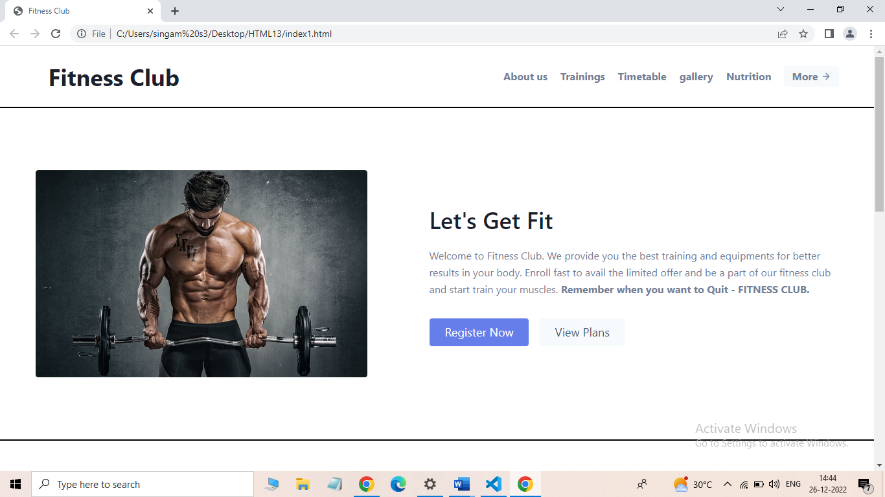

2.Header:
<header class="text-gray-600 body-font">
<div class="container mx-auto flex flex-wrap p-5 flex-col md:flex-row items-center">
<a class="flex title-font font-medium items-center text-gray-900 mb-4 md:mb-0">
<span class="ml-5 text-4xl"><b>Fitness Club</b></span>
</a>
<nav class="md:ml-auto flex flex-wrap items-center text-base justify-center">
<a class="mr-5 hover:text-gray-900"><b>About us</b></a>
<a class="mr-5 hover:text-gray-900"><b>Trainings</b></a>
<a class="mr-5 hover:text-gray-900"><b>Timetable</b></a>
<a class="mr-5 hover:text-grey-900"><b>gallery</b></a>
<a class="mr-5 hover:text-gray-900"><b>Nutrition</b></a>
</nav>
<button class="inline-flex items-center bg-gray-100 border-0 py-1 px-3 focus:outline-none hover:bg-gray-200 rounded text-base mt-4 md:mt-0"><b>More</b>
<svg fill="none" stroke="currentColor" stroke-linecap="round" stroke-linejoin="round" stroke-width="2" class="w-4 h-4 ml-1" viewBox="0 0 24 24">
<path d="M5 12h14M12 5l7 7-7 7"></path>
</svg>
</button>
</div>
</header>

3.Footer:
<footer class="text-gray-400 bg-gray-900 body-font">
<div class="container px-5 py-24 mx-auto">
<div class="flex flex-wrap md:text-left text-center order-first">
<div class="lg:w-1/4 md:w-1/2 w-full px-4">
<h2 class="title-font font-medium text-white tracking-widest text-sm mb-3">Quick Links</h2>
<nav class="list-none mb-10">
<li>
<a class="text-gray-400 hover:text-white">About Us</a>
</li>
<li>
<a class="text-gray-400 hover:text-white">Our Team</a>
</li>
<li>
<a class="text-gray-400 hover:text-white">Testimonials</a>
</li>
<li>
<a class="text-gray-400 hover:text-white">Work Culture</a>
</li>
</nav>
</div>
<div class="lg:w-1/4 md:w-1/2 w-full px-4">
<h2 class="title-font font-medium text-white tracking-widest text-sm mb-3"></h2>
<nav class="list-none mb-10">
<li>
<a class="text-gray-400 hover:text-white">Events</a>
</li>
<li>
<a class="text-gray-400 hover:text-white">Promotions</a>
</li>
<li>
<a class="text-gray-400 hover:text-white">Careers</a>
</li>
<li>
<a class="text-gray-400 hover:text-white">Group Progarm</a>
</li>
</nav>
</div>
<div class="lg:w-1/4 md:w-1/2 w-full px-4">
<h2 class="title-font font-medium text-white tracking-widest text-sm mb-3"></h2>
<nav class="list-none mb-10">
<li>
<a class="text-gray-400 hover:text-white">Gallery</a>
</li>
<li>
<a class="text-gray-400 hover:text-white">Franchise</a>
</li>
<li>
<a class="text-gray-400 hover:text-white">Blogs</a>
</li>
<li>
<a class="text-gray-400 hover:text-white">Advertisment</a>
</li>
</nav>
</div>
<div class="lg:w-1/4 md:w-1/2 w-full px-4">
<h2 class="title-font font-medium text-white tracking-widest text-sm mb-3">Sign Up</h2>
<div class="flex xl:flex-nowrap md:flex-nowrap lg:flex-wrap flex-wrap justify-center items-end md:justify-start">
<div class="relative w-40 sm:w-auto xl:mr-4 lg:mr-0 sm:mr-4 mr-2">
<label for="footer-field" class="leading-7 text-sm text-gray-400">Enter Your E-mail</label>
<input type="text" id="footer-field" name="footer-field" class="w-full bg-gray-800 rounded border bg-opacity-40 border-gray-700 focus:bg-transparent focus:ring-2 focus:ring-indigo-900 focus:border-indigo-500 text-base outline-none text-gray-100 py-1 px-3 leading-8 transition-colors duration-200 ease-in-out">
</div>
<button class="lg:mt-2 xl:mt-0 flex-shrink-0 inline-flex text-white bg-indigo-500 border-0 py-2 px-6 focus:outline-none hover:bg-indigo-600 rounded">Next</button>
</div>
<p class="text-gray-500 text-sm mt-2 md:text-left text-center">Sign Up For Our Mailing List To
<br class="lg:block hidden">Get Latest Updates And Offers
</p>
</div>
</div>
</div>
<div class="bg-gray-800 bg-opacity-75">
<div class="container px-5 py-6 mx-auto flex items-center sm:flex-row flex-col">
<a class="flex title-font font-medium items-center md:justify-start justify-center text-white">
<svg xmlns="http://www.w3.org/2000/svg" fill="none" stroke="currentColor" stroke-linecap="round" stroke-linejoin="round" stroke-width="2" class="w-10 h-10 text-white p-2 bg-indigo-500 rounded-full" viewBox="0 0 24 24">
</svg>
<span class="ml-3 text-xl">Fitness Club</span>
</a>
<p class="text-sm text-gray-400 sm:ml-6 sm:mt-0 mt-4">© 2022 Fitness Club —
<a href="" class="text-gray-500 ml-1" target="_blank" rel="noopener noreferrer">@fitnessclub</a>
</p>
<span class="inline-flex sm:ml-auto sm:mt-0 mt-4 justify-center sm:justify-start">
<a class="text-gray-400">
<svg fill="currentColor" stroke-linecap="round" stroke-linejoin="round" stroke-width="2" class="w-5 h-5" viewBox="0 0 24 24">
<path d="M18 2h-3a5 5 0 00-5 5v3H7v4h3v8h4v-8h3l1-4h-4V7a1 1 0 011-1h3z"></path>
</svg>
</a>
<a class="ml-3 text-gray-400">
<svg fill="currentColor" stroke-linecap="round" stroke-linejoin="round" stroke-width="2" class="w-5 h-5" viewBox="0 0 24 24">
<path d="M23 3a10.9 10.9 0 01-3.14 1.53 4.48 4.48 0 00-7.86 3v1A10.66 10.66 0 013 4s-4 9 5 13a11.64 11.64 0 01-7 2c9 5 20 0 20-11.5a4.5 4.5 0 00-.08-.83A7.72 7.72 0 0023 3z"></path>
</svg>
</a>
<a class="ml-3 text-gray-400">
<svg fill="none" stroke="currentColor" stroke-linecap="round" stroke-linejoin="round" stroke-width="2" class="w-5 h-5" viewBox="0 0 24 24">
<rect width="20" height="20" x="2" y="2" rx="5" ry="5"></rect>
<path d="M16 11.37A4 4 0 1112.63 8 4 4 0 0116 11.37zm1.5-4.87h.01"></path>
</svg>
</a>
<a class="ml-3 text-gray-400">
<svg fill="currentColor" stroke="currentColor" stroke-linecap="round" stroke-linejoin="round" stroke-width="0" class="w-5 h-5" viewBox="0 0 24 24">
<path stroke="none" d="M16 8a6 6 0 016 6v7h-4v-7a2 2 0 00-2-2 2 2 0 00-2 2v7h-4v-7a6 6 0 016-6zM2 9h4v12H2z"></path>
<circle cx="4" cy="4" r="2" stroke="none"></circle>
</svg>
</a>
</span>
</div>
</div>
</footer>

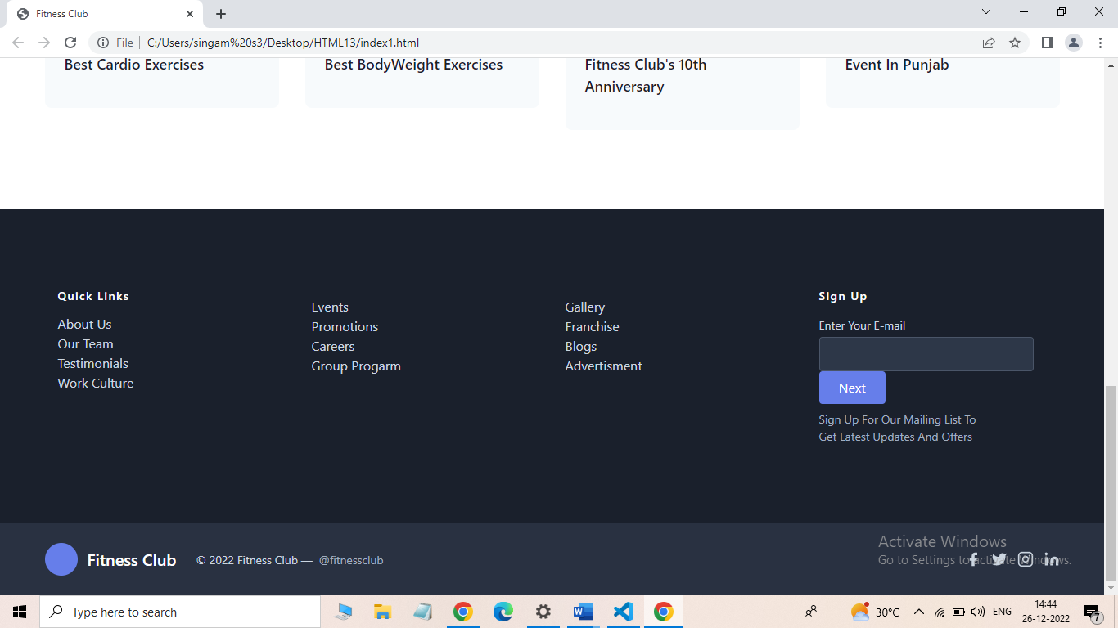

4.CSS:
<style>
hr{
height:0.5px;
width:auto;
margin:0;
box-sizing:border-box;
background-color:rgb(93, 15, 129);
border:solid 1px;
transition:0.5s;

}
.container.column{
width:32%;
height:auto;
position:relative;
overflow:hidden;
}
.footer.h2{display:inline-flex;
width:auto;
height:100px;
background:#FF7900;
margin-top:40px;

}
.footer.contact p{
color:white;
}

</style>
